**Fits of wild-type (A-C) and mutant (D-E) data from Ramentol et al. (2020) using a four-state model with detailed balance (B) or without detailed balance (A, C-E).**

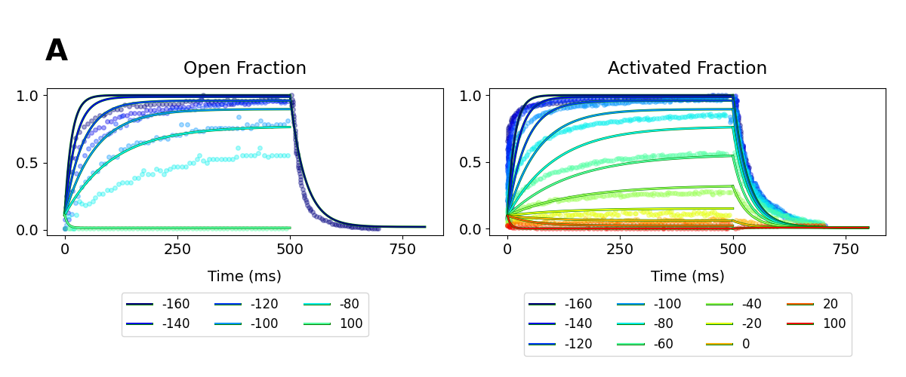

A. Fit of wild-type normalized current (left) and fluorescence (right) data **without** detailed balance. Both activation **and** deactivation time courses were used in the fit.

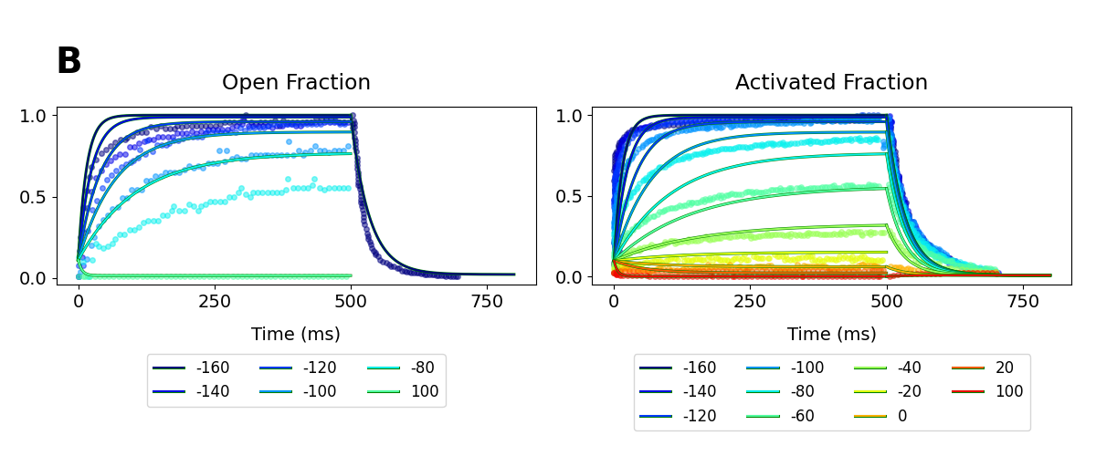B. Fit of wild-type normalized current (left) and fluorescence (right) data **with** detailed balance. Both activation **and** deactivation time courses were used in the fit.

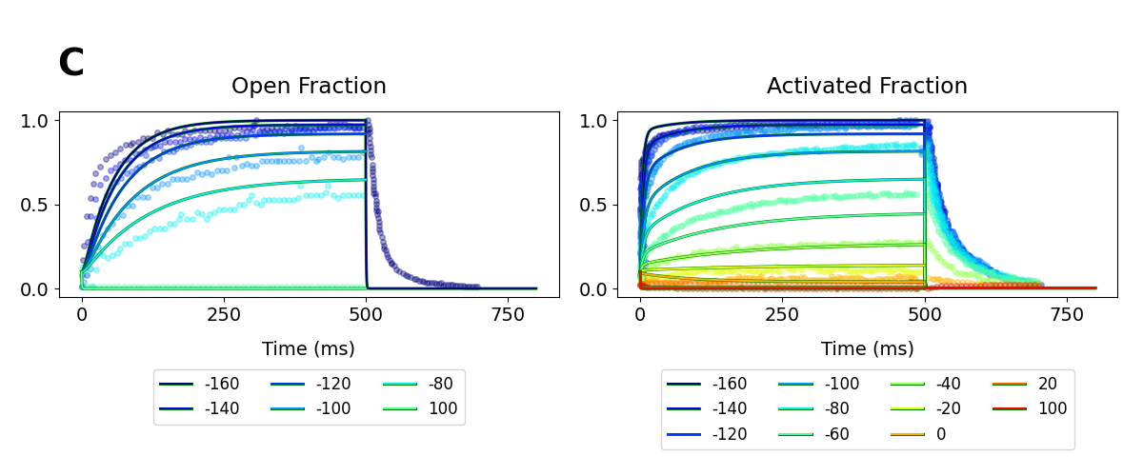

C. Fit of wild-type normalized current (left) and fluorescence (right) data **without** detailed balance. **Only** activation time courses were used in the fit.

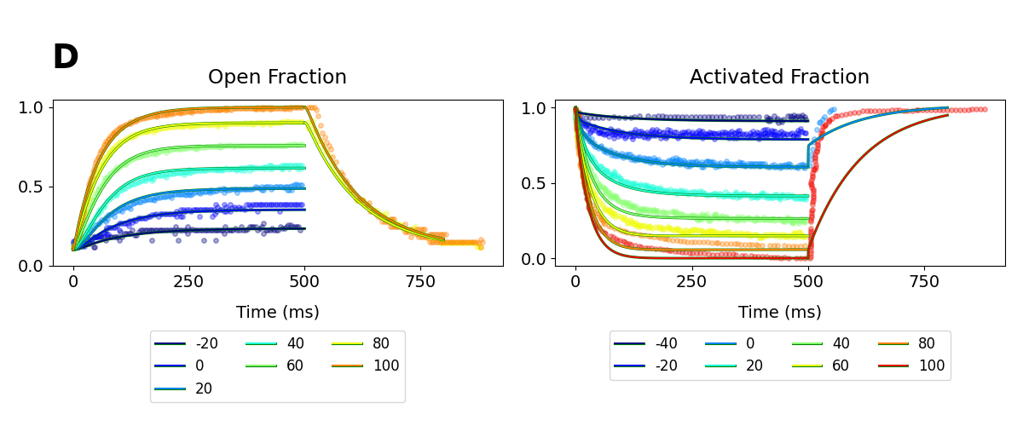

D. Fit of mutant normalized current (left) and fluorescence (right) data **without** detailed balance. **Only** activation time courses were used in the fit

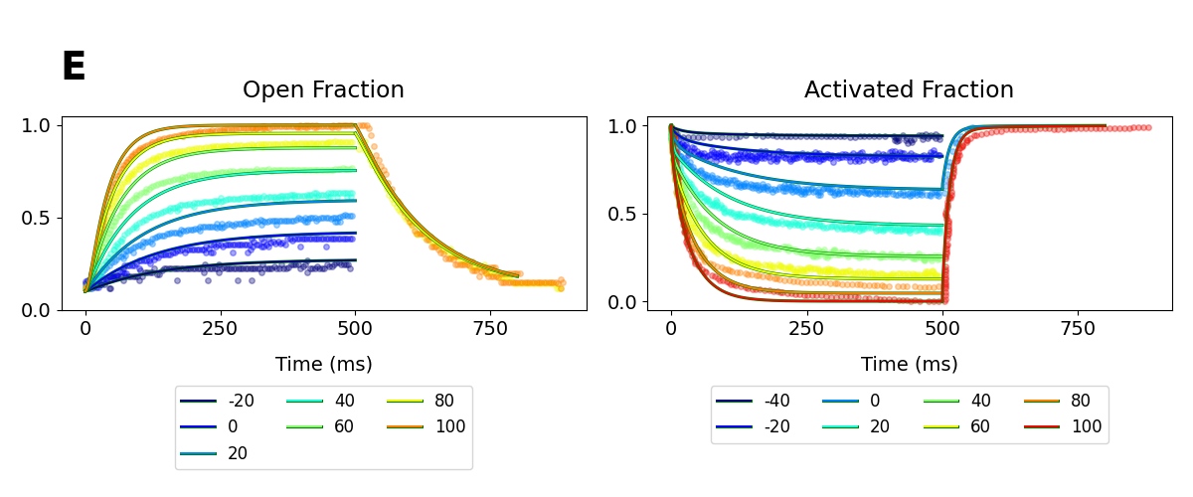

E. Fit of mutant normalized current (left) and fluorescence (right) data **without** detailed balance. Both activation **and** deactivation time courses were used in the fit